**LAB ASSIGNMENTS**

1. **YACC**

**File: ic.arithemtic.l**

ALPHA [A-Za-z]

DIGIT [0-9]

%%

{ALPHA}({ALPHA}|{DIGIT})* return ID;

{DIGIT}+ {yylval = atoi(yytext); return NUM; }

[\n\t] yyterminate();

. return yytext[0];

%%

**File: ic.arithemtic.l**

%token ID NUM

%right '='

%left '+' '-'

%left '*' '/'

%left UMINUS

%%

S: ID{ push(); }'='{ push(); }E{ codegen_assign(); }

;

E: E'+'{ push(); }T{ codegen(); }

| E'-'{ push(); }T{ codegen(); }

| T

;

T: T'*'{ push(); }F{ codegen(); }

| T'/'{ push(); }F{ codegen(); }

| F

;

F: '('E')'

| '-'{ push(); }F{codegen_umin(); }%prec UMINUS

| ID{ push(); }

| NUM{ push(); }

;

%%

#include "lex.yy.c"

#include <ctype.h>

char st[100][10];

int top = 0;

char i_[2] = "0";

char temp[2] = "t";

int main()

{

printf("Enter expresstion: ");

yyparse();

}

void push()

{

strcpy(st[++top], yytext);

}

void codegen()

{

strcpy(temp, "t");

strcat(temp, i_);

printf("%s = %s %s %s\n", temp, st[top - 2], st[top - 1], st[top]);

top -= 2;

strcpy(st[top], temp);

i_[0]++;

}

void codegen_umin()

{

strcpy(temp, "t");

strcat(temp, i_);

printf("%s = -%s\n", temp, st[top]);

top--;

strcpy(st[top], temp);

i_[0]++;

}

void codegen_assign()

{

printf("%s = %s\n", st[top - 2], st[top]);

top -= 2;

}

**OUPUT**

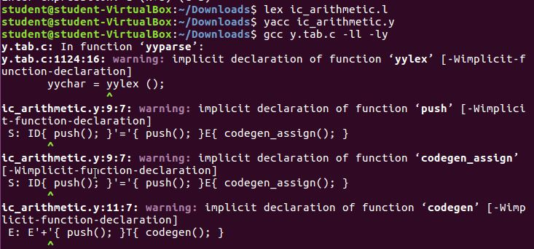

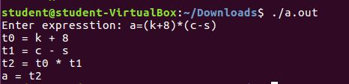

1. **POSTFIX EVALUTION**

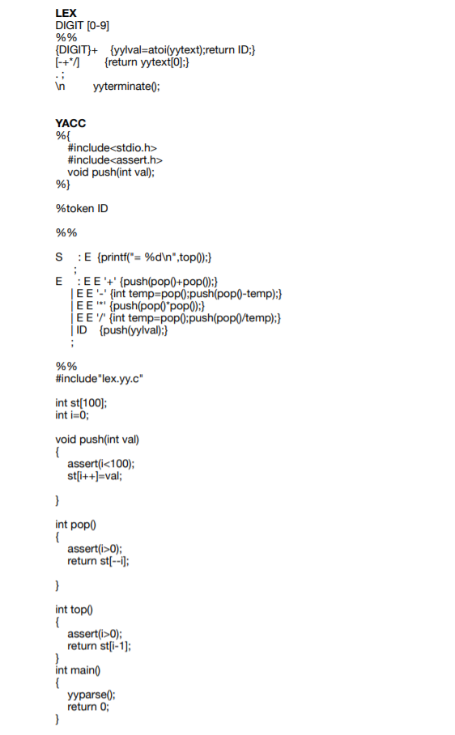

**OUTPUT**

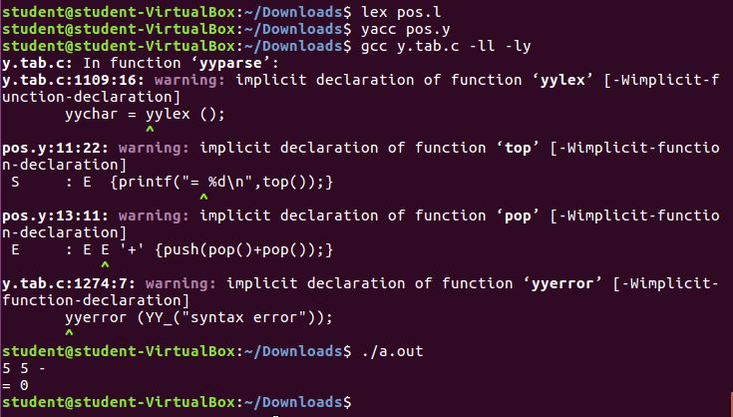

1. **DESK CALCULATOR**

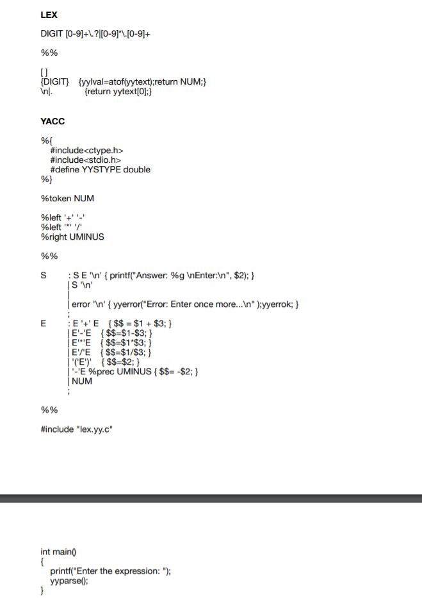

**OUTPUT**

